Imagine
On a cold, fretful afternoon in early October 1872, a hansom cab drew up outside the offices of Lockhart and Selby, Shipping Agents in the financial heart of London, and a young girl got our and paid the driver.
She was a person of sixteen or so – alone, and uncommonly pretty. She was slender and pale, and dressed in mourning, with a black bonnet under which she tucked back a straying twist of blonde hair that the wind had teased loose. She has unusually dark brown eyes for one so fair. Her name was Sally Lockhart; and within fifteen minutes she was going to kill a man. (‘The Ruby in the Smoke’ by Philip Pullman)

Alex was sure he was going to suffocate.
Crouched in the tiny, pitch-black bucketing space, legs drawn up to his chin, sweat running down his face, handkerchief sodden, head pounding, the panic raged inside him. He wanted to scream and beat at the plastic walls. Instead, he remained petrified by the continuous vibration, the sour smell of his tomb. (‘Day of the Dead’ by Anthony Masters)

Discuss: What makes an attention-grabbing opening to a story. Use the 2 examples to help.
Write: To create an exciting opening to a story using at least one of these 4 items
A rusty key 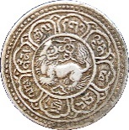A foreign coin 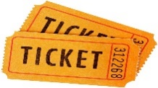A bus ticket A button
__________________________________________________________________________________________________________________________________________________________________________________________________________________________________________________________________________________________________________________________________________________________________________________________________________________________________________________________________
_________________________________________________________________________________________________________________________________________________________________________________________________________________________________
___________________________________________________________________________
__________________________________________________________________________________________________________________________________________________________________________________________________________________________________________________________________________________________________________________________________________________________________________________________________________________________________________________________________
_________________________________________________________________________________________________________________________________________________________________________________________________________________________________
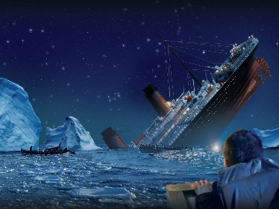
Recount
The Titanic: From A Lifeboat, 15 April 1912 Mrs D H Bishop

We did not begin to understand the situation till we were perhaps a mile of more away from the Titanic. Then we could see the rows of lights along the decks began to slant gradually upward from the bow. Very slowly the lines of light began to point downward at a greater and greater angle. The sinking was so slow that you could not perceive the lights of the deck changing their position. The slant seemed to be greater about every quarter of an hour. That was the only difference.
In a couple of hours, though, she began to go down more rapidly. Then the fearful sight began. The people in the ship were just beginning to realise how great their danger was. When the forward part of the ship dropped suddenly at a faster rate, so that the upward slope became marked, there was a sudden rush of passengers on all decks towards the stern. It was like a wave. We could see the great black mass of people in the steerage sweeping to the rear part of the boat and breaking through into the upper decks. At the distance of about a mile we could distinguish everything through the night, which was perfectly clear. We could make out the increasing excitement on board the boat as the people, rushing to and fro, caused the deck lights to disappear and reappear as they passed in front of them.
This panic went on, it seemed, for an hour. Then suddenly the ship seemed to shoot up out of the water and stand there perpendicularly. It seemed to us that it stood upright in the water for four full minutes. Then it began to slide gently downwards. Its speed increased as it went down head first, so the stern shot down with a rush.
The lights continued to burn till it sank. We could see the people packed densely in the stern till it was gone…
As the ship sank we could hear the screaming a mile away. Gradually it became fainter and fainter and died away. Some of the lifeboats that had room for more might have gone to their rescue, but it would have meant that those who were in the water would have swarmed aboard and sunk her.

Discuss: what needs to be included in an eye witness account. Use the Titanic example.
Write: to describe an event which you witnessed from beginning to end OR an imagined first-hand account of a significant historical event about which you have some knowledge.
_______________________________________________________________________________________________________________________________________________________________________________________________________________________________________________________________________________________________________________________________________________________________________________________
_________________________________________________________________________________________________________________________________________________________________________________________________________________________________
___________________________________________________________________________
___________________________________________________________________________
______________________________________________________________________________________________________________________________________________________________________________________________________________________________________________________________________________________________________________________________________________________________________________________E

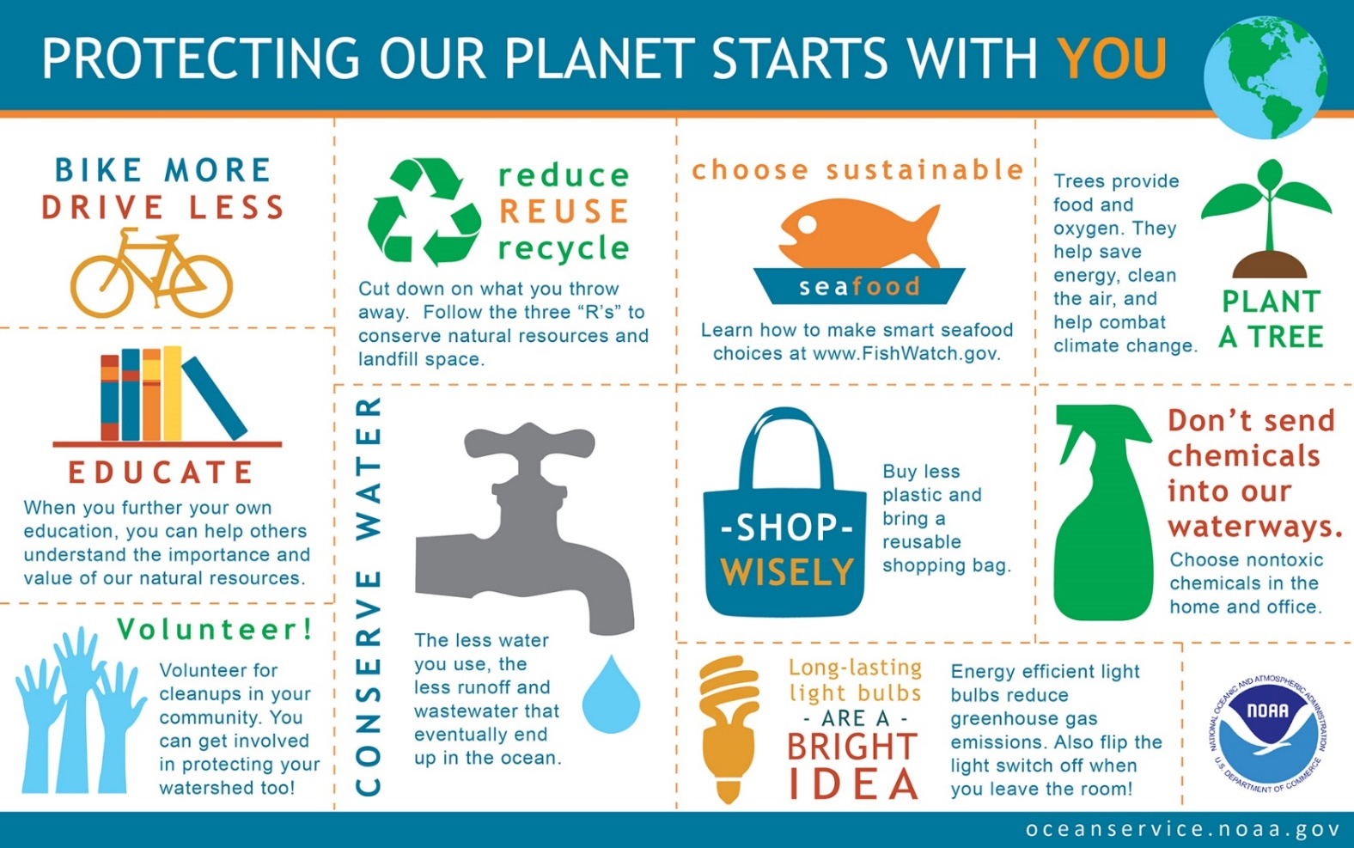
Explain

Discuss: How to explain clearly. Who is responsible for ensuring the future of the planet?
Write: To explain how individuals can help to protect the planet.
__________________________________________________________________________________________________________________________________________________________________________________________________________________________________________________________________________________________________________________________________________________________________________________________________________________________________________________________________
_________________________________________________________________________________________________________________________________________________________________________________________________________________________________
___________________________________________________________________________
__________________________________________________________________________________________________________________________________________________________________________________________________________________________________________________________________________________________________________________________________________________________________________________________________________________________________________________________________

Persuade
In praise of … pencil cases
One of the small, reliable pleasures of returning to school is a pencil case. A wooden, brassbound model with sliding trays and a lid would be perfect, but even the tattiest plastic model with a film tie-in princess for decoration holds some of the magic inherent in the form. A pencil case holds the promise of a new and better-organised life. To hold it is to have faith that starting this term, everything will be different. Our minds will be sharp as a fresh pencil, our thoughts as straight as rulers, and our resolutions firm as the strokes of an unblemished rubber when it erases even the faintest memory of a wrongly drawn line. The natural state of all writing instruments is quiet insurrection. They are constantly rolling and sidling towards freedom and concealment. But a pencil case holds its treasures securely and in order, even the free-rolling Biro. If only we could organise our own thoughts – or even our children – quite as simply.

In praise of … charging for plastic bags
We've all seen them: plastic carrier bags clinging to bushes, trees, street signs and railway lines. They're ugly. They're annoying. They ruin our landscapes, clog up our kitchen cabinets and, worse, end up in our landfills and waterways, harming wildlife and taking up to 1,000 years to decompose. And yet we can't seem to stop using them without an incentive. That's why New York City is eminently sensible to propose that stores charge 10 cents (or just over 6p), for every plastic bag a customer uses. It's a small fee, but it can have a big impact, as Ireland, which began charging in 2002, has shown. Plastic bag usage in the republic is down over 90%. From countries to cities, from Wales to Washington DC to Portland, Oregon, there have been similar successes after their bans. Even China has a ban on certain types of bags. Reducing our reliance on plastic bags is a little step, but one we're ready to get carried away with.

Discuss: the persuasive techniques used in the 2 examples
Write: in praise of something you appreciate/admire
__________________________________________________________________________________________________________________________________________________________________________________________________________________________________________________________________________________________________________________________________________________________________________________________________________________________________________________________________
_________________________________________________________________________________________________________________________________________________________________________________________________________________________________
___________________________________________________________________________
__________________________________________________________________________________________________________________________________________________________________________________________________________________________________________________________________________________________________________________________________________________________________________________________________________________________________________________________________
________________________________________________________
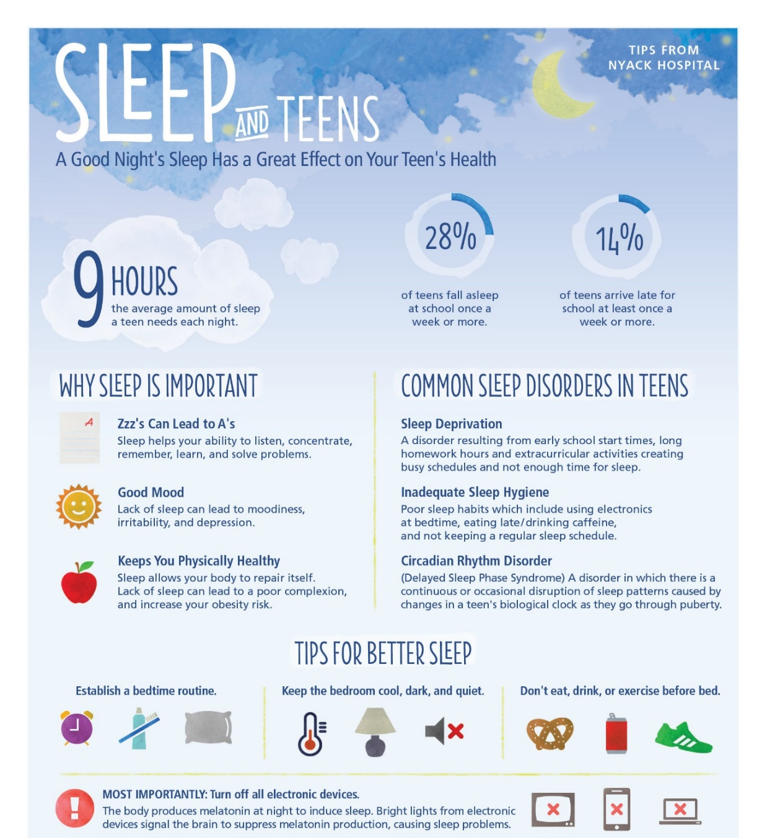
Argue

Discuss:
How you would
put forward a
convincing
argument for
something.
What are the
benefits of a
later school start
time for
secondary school
pupils?

Write: An argument for later school hours.
____________________________________________________________________________________________________________________________________________________________________________________________________________________________________________________________________________________________________________________________________________________________________________________________________________________________________________________________________________________________________________________________________________________________________________________________________________________________________________________________________________________________________________________________________________________________________________________________________________________________________________________
________________________________________________________________________________________________________________________________________________________________________________________________________________________________________________________________________________________________________________________________________
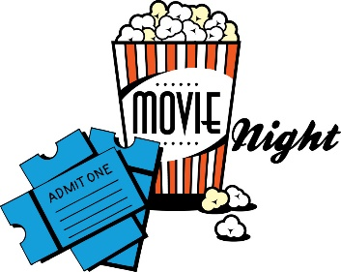
Review
Van Helsing – Philip French
There are exciting moments - especially a carriage chase while Van Helsing and Anna are attempting to transport Frankenstein's sweet-natured monster back to Rome for his safety. But the yawning gaps in the landscape down which characters plunge are accompanied by yawning gaps when the audience (though not the restless film) pauses in an attempt to make sense of what is going on. The movie has no soul, no magic, no feeling for character, nothing for us to care about. At the end, when the director makes a stab at elegiac pathos, we realise how far short of the often deeply moving 1930s Universal classics his film falls.

Spiderman 3 – Peter Bradshaw
SM3 has its moments, but it's over-long and messy with a number of disjointed storylines. There's no clear villain to boo and, by the end, no clear hero to cheer. Instead of one obvious, compelling enemy, there are two. Or three if you count another who pops up right at the end.
The series is now beginning to resemble the Christopher Reeve Superman movies at their later sequel stage: a fair bit of zip, and some terrific-looking Manhattan streetscape battle scenes, but no satisfyingly unified story, and muddied by the fact that the love interest now knows the hero's secret identity.
Worst of all, it's crippled by an inflation of villain-value. Where once a single baddie would do, now you need two or three. As he scampers around the bathtub of popular culture, Spidey is beginning to exhaust everyone's patience. The time has come for someone to produce a rolled-up newspaper the size of a subway train and bring it down with an almighty crash.

Discuss: films you have seen that disappointed. How do these reviewers convey their unhappiness.
Write: to review a film that you hated
__________________________________________________________________________________________________________________________________________________________________________________________________________________________________________________________________________________________________________________________________________________________________________________________________________________________________________________________________
_________________________________________________________________________________________________________________________________________________________________________________________________________________________________
___________________________________________________________________________
__________________________________________________________________________________________________________________________________________________________________________________________________________________________________________________________________________________________________________________________________________________________________________________________________________________________________________________________________
___________________________________________________________________________
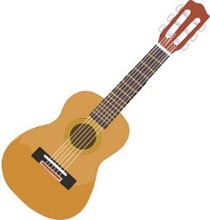
Remember and Reflect
The most valuable possession in my room is an old, slightly warped cherry red guitar-the first instrument I taught myself how to play. It's nothing fancy, just a Madeira folk guitar, all scuffed and scratched and finger-printed. At the top is a bramble of copper-wound strings, each one hooked through the eye of a silver tuning key. The strings are stretched down a long, slim neck, its frets tarnished, the wood worn by years of fingers pressing chords and picking notes. The body of the Madeira is shaped like an enormous yellow pear, one that was slightly damaged in shipping. The wood has been chipped and gouged to grey, particularly where the pick guard fell off years ago. No, it's not a beautiful instrument, but it still lets me make music, and for that I will always treasure it.

Discuss: What prompts a strong memory? What techniques are used by this writer to show how important this object was/is?
Write: to describe and reflect on the significance of a favourite childhood toy
__________________________________________________________________________________________________________________________________________________________________________________________________________________________________________________________________________________________________________________________________________________________________________________________________________________________________________________________________
_________________________________________________________________________________________________________________________________________________________________________________________________________________________________
___________________________________________________________________________
__________________________________________________________________________________________________________________________________________________________________________________________________________________________________________________________________________________________________________________________________________________________________________________________________________________________________________________________________
__________________________________________________________________________________________________________________________________________________________________________________________________________________________________________________________________________________________________________________________________________________________________________________________________________________________________________________________________
_________________________________________________________________________________________________________________________________________________________________________________________________________________________________
___________________________________________________________________________
___________________________________________________________________________
Instruct
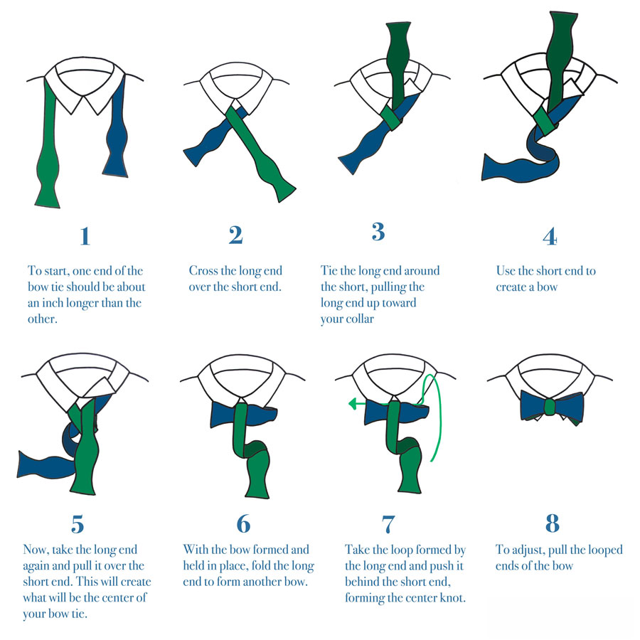
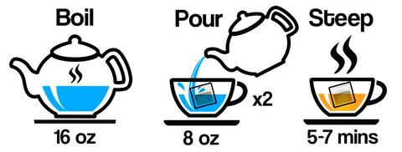

Inspire

Discuss: what makes a good set
of instructions
Write:
- instructions on how to make the most
scrumptious quick snack possible OR
- instructions on how to keep teachers/
parents/carers sweet OR
- instructions on how to be a “couch
potato”

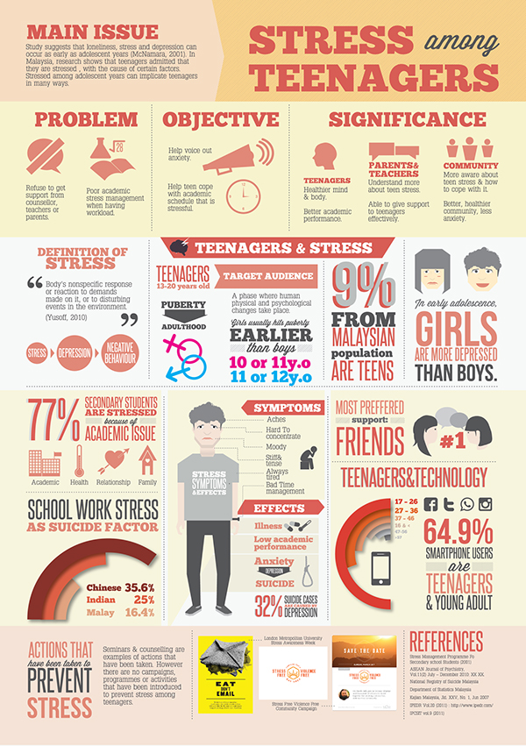
Inform

Discuss: What causes
stress among teenagers
and how
it can be reduced.
The difference between
fact and opinion.

Write: To give information about the main cause of stress among teenagers, its main effect and a solution
__________________________________________________________________________________________________________________________________________________________________________________________________________________________________________________________________________________________________________________________________________________________________________________________________________________________________________________________________
_________________________________________________________________________________________________________________________________________________________________________________________________________________________________
___________________________________________________________________________
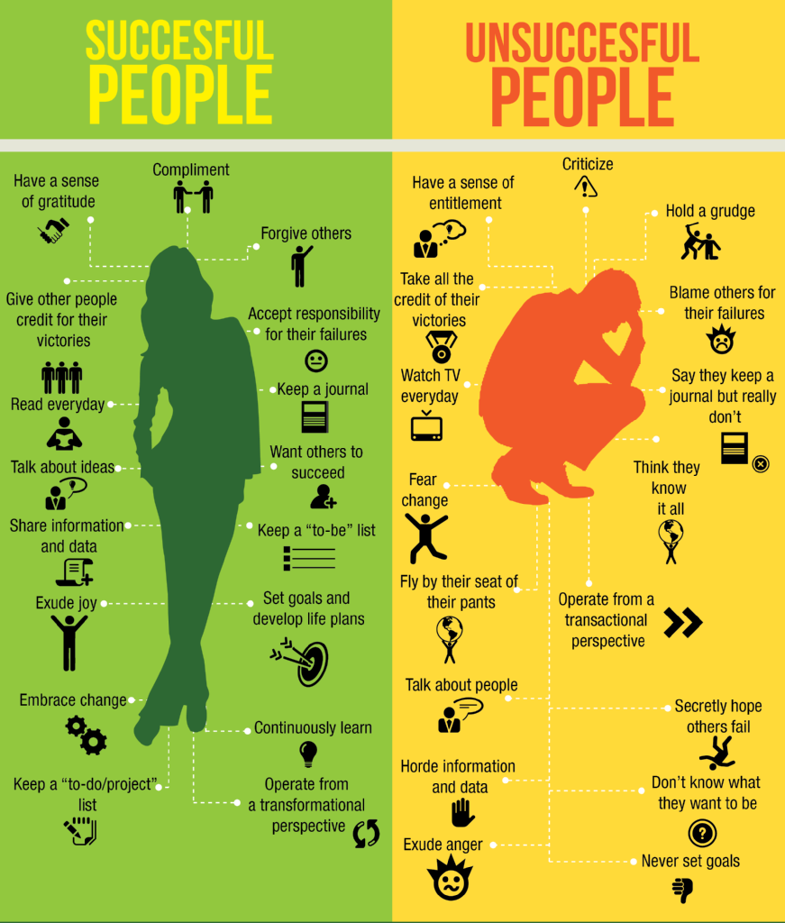
Compare and Contrast

Discuss: How you ensure
success in a task and the
things that get in the way
of your success

Write: To compare the behaviour of successful and unsuccessful people.
__________________________________________________________________________________________________________________________________________________________________________________________________________________________________________________________________________________________________________________________________________________________________________________________________________________________________________________________________
_________________________________________________________________________________________________________________________________________________________________________________________________________________________________
___________________________________________________________________________
__________________________________________________________________________________________________________________________________________________________________________________________________________________________________________________________________________________________________________________________________________________________________________________________________________________________________________________________________
Inspire
Four score and seven years ago our fathers brought forth on this continent, a new nation, conceived in liberty, and dedicated to the proposition that all men are created equal.
Now we are engaged in a great civil war, testing whether that nation, or any nation so conceived and so dedicated, can long endure. We are met on a great battlefield of that war. We have come to dedicate a portion of that field, as a final resting place for those who here gave their lives that that nation might live. It is altogether fitting and proper that we should do this.
But in a larger sense, we cannot dedicate – we cannot consecrate – we cannot hallow – this ground. The brave men, living and dead, who struggled here, have consecrated it, far above our poor power to add or detract. The world will little note, nor long remember, what we say here, but it can never forget what they did here. It is for us the living, rather, to be dedicated here to the unfinished work which they who fought here have thus far so nobly advanced. It is rather for us to be here dedicated to the great task remaining before us – that from these honoured dead we take increased devotion to that cause for which they gave the last full measure of devotion – that we here highly resolve that these dead shall not have died in vain – that this nation, under God, shall have a new birth of freedom – and that government of the people, by the people, for the people, shall not perish from the earth.
Abraham Lincoln – The Gettysburg Address, Nov 19 1863
Read Lincoln’s famous speech and watch the following speeches
JFK - We choose to go to the moon https://www.youtube.com/watch?v=g25G1M4EXrQ
Braveheart
https://www.youtube.com/watch?v=hIvRkjOd1f8
Discuss: what makes an inspirational speech?
Write: Imagine you are a football manager or other sports coach before an important final.
Write the speech you will give to motivate your team OR Imagine you are a king/queen/ leader who has just come to power. Write your speech to your subjects, telling them what sort of ruler you are going to be.
_________________________________________________________________________________________________________________________________________________________________________________________________________________________________________________________________________________________________________________________________________________________________________________________________________________________________________________________________
_________________________________________________________________________________________________________________________________________________________________________________________________________________________________
___________________________________________________________________________
____________________________________________________________________________________________________________________________________________________________________________________________________________________________________________________________________________________________________________
Compare two fast foods/ or two fast food restaurants. Say which you prefer and why.
OR
Present an argument in favour of a four-day school week.
OR
Write an argument against school uniform.
OR
You are the only carrot left in the fridge. Write about your feelings and your hopes for the future.
OR
You are an old coin that someone has found in the street. Write about your life.
OR
What if humans had tails? Write a short essay in which you explain how the world would be different.
OR
Write a review of a meal you recently enjoyed. Describe it and say what you liked about it and what could make it even better.
OR
Write a review an item of clothing that you like to wear: shoes, jacket, leisure wear, hats etc…
OR
Write a review of a place you have recently visited. Point out its most notable features and say what you liked/disliked about it.
OR
Write a page about the rules of a game that you play or have played when you were younger.
OR
Write a set of instructions on how to stay in bed as long as possible but still get to school on time
OR
What if you were invisible? Describe what things you would do and where you would like to go.
OR
“Kids believe anything.” Did you believe anything as a child that you later found out to be untrue?
OR
Write a letter to the head teacher of your school requesting that all tests and exams be banned.

