Let’s remember WITNESS COMBS
Word choice – interesting verbs, precise nouns, powerful adjectives and adverbs
Imagery – interesting, original images; NO cliches
Theme – have something to say
Narrative style – 1st or 3rd person? Dual narrative? 2nd person?
Ending – that matches what has gone before, that makes the reader think or react
Structure that is clear and easy to follow – opening – one key event – climax – resolution
Setting that is believable
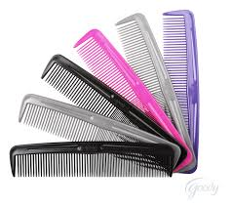
Characters – focus on developing 1 or 2 only
Opening Hook – to reel in the reader right from the start
Motif or symbol to represent or emphasise a key idea or theme
Balance of narrative (events), description and dialogue
Sentence structure that is varied – short, long, minor, question, exclamation…

