“No matter how busy you may think you are, you must find time for reading, or surrender yourself to self-chosen ignorance.”
^{- Confucius}
S3 Literacy Challenge
- Reading
- Writing
- Spoken Performance
Name:_____________________ Class:______
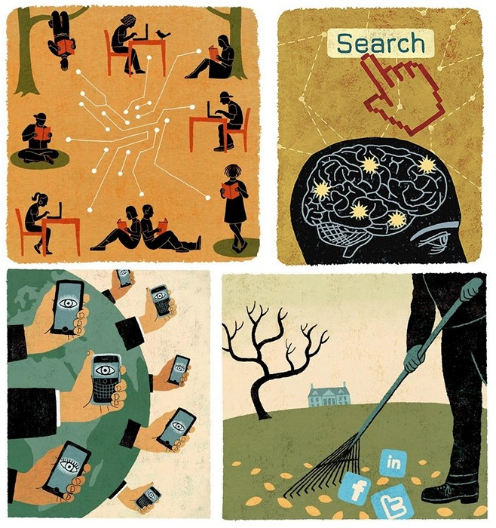
“Reading a book is like re-writing it for yourself. You bring to a novel, anything you read, all your experience of the world. You bring your history and you read it in your own terms.” Angela Carter
READING
YOUR READING CHALLENGE:
Discover thought- provoking language and ideas wherever you can.
Language can be read wherever it can be found not just in written words but in spoken language too.
FILMS 5+ NOVELS

2 BLOGS ADVERTS

DRAMA 20 + ARTICLES
3 + DOCUMENTARIES
TOP REASONS FOR READING #1
Be truly human.
At its heart, reading the narratives, discussions and arguments of others is about exploring our humanity. As a student of the language, you enter into a discussion of what it means to be a person. Ultimately ulterior motives, such as appearing smart, fall to the wayside. Reading great writing is the master course in self-development!

TOP REASONS FOR READING #1

Reading Challenge – FICTION
Read a novel featuring a protagonist of your own age.
What did you learn from their story?

Why would you recommend this novel to others?

FICTION
FAMOUS LITERARY CHILD CHARACTERS:
Holden in The Catcher In The Rye by JD Salinger
The Lisbon sisters in The Virgin Suicides by Jeffrey Euginedes
Alex in A Clockwork Orange by Anthony Burgess
Suzy Salmon in The Lovely Bones by Alice Sebold
Ponyboy in The Outsiders by SE Hinton
Frank in The Wasp Factory by Iain Banks

GREAT SHORT NOVELS:
The Strange Case of Dr Jekyll and Mr Hyde by Robert Louis Stevenson
The Great Gatsby by F Scott Fitzgerald
Animal Farm by George Orwell
Cannery Row by John Steinbeck
The Stranger by Albert Camus

The Stranger by Albert Camus

Reading Challenge – FICTION
No time to read? Pick a short classic.
What did you learn from their story?

Why would you recommend this novel to others?

REASON TO READ # 2: Improve your ability to comprehend. Although the great books weren’t written for specialists and experts, they can be a tough read. Once you get through a few of the more challenging books, you’ll find it easier to comprehend all kinds of works. As a more confident reader, you won’t need to shy away from academic articles or historical texts. The entire body of English writing will be in your domain.

Reading Challenge – FICTION
Read a novel recommended by someone at home.
What did you learn from their story?

Why would you recommend this novel to others?

Reading Challenge – FICTION
Read a novel from the Upper School Reading Group list.
What did you learn from their story?

Why would you recommend this novel to others?

Reading Challenge – FICTION
Make a collage of images inspired by a novel you have read and give it to your teacher as a lovely gift!
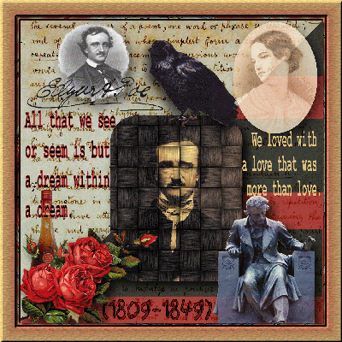

Reading Challenge – FICTION
Read a novel of your choice.
What did you learn from the story?

Why would you recommend this novel to others?

Reading Challenge – FICTION
Read a novel of your choice.
What did you think of the plot or characters?

Why would you recommend this novel to others?

Reading Challenge – FICTION
Read a novel of your choice.
What did you learn from their story?

Why would you recommend this novel to others?

“Blogging is to writing what extreme sports are to athletics: more free-form, more accident-prone, less formal, more alive. It is, in many ways, writing out loud.” Andrew Sullivan – What do you think?
Pick a blog and follow it. Track the blogger’s views below. If you don’t like their views, or if you get bored, follow someone new!
Blogger | Date & Topic | Viewpoint

Try these or pick your own:
http://narrativelyspeaking.blogspot.co.uk/2012/05/narratively-speaking-in-top-ten-uk.html
http://well-la-dee-da.blogspot.co.uk/
http://www.guardian.co.uk/sport/blog
Reading Challenge – FICTION
Read a novel recommended by someone at home.
What did you learn from their story?

Why would you recommend this novel to others?

Reading Challenge – FICTION
Read a novel from the Upper School Reading Group list.
What did you learn from their story?

Why would you recommend this novel to others?

Reading Challenge – FICTION
Read a novel of your choice.
What did you learn from their story?

Why would you recommend this novel to others?

? ? ? ? ? ? ? ? ? DID YOU KNOW? ? ? ? ? ? ?
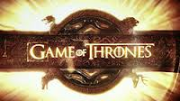
Did you know that author of fantasy series Ice and Fire and Game of Thrones creator George R. R. Martin is worth an estimated $30 million?
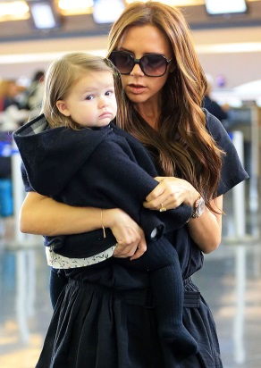
Did you know that David and Victoria Beckham’s daughter is named after the author of Victoria’s favourite novel, To Kill a Mockingbird by Harper Lee?

Did you know that of the fifteen films Emma Watson has starred in, 13 are based on novels and include the following titles: Harry Potter series, Ballet Shoes, The Tale of Despereaux, My Week With Marilyn, The Perks of Being a Wallflower and Noah?
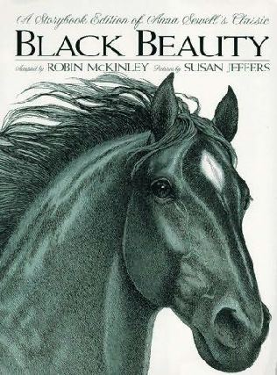
Did you know that Anna Sewell’s classic Black Beauty was banned in apartheid South Africa because of the adjective “black” used in the title?

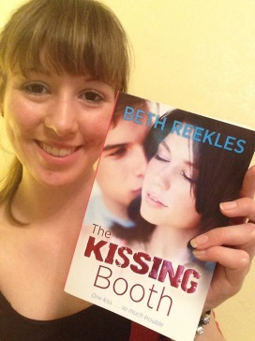
Did you know that in 2012, 17 year-old Welsh schoolgirl Beth Reekles secured a three book deal with Random House publishers after posting her first novel, The Kissing Booth, online on Wattpad in 2011?

? ? ? ? ? ? ? ? ? ? ? ? ? ? ? ? ? ? ? ? ? ? ? ? ? ? ? ?
“Read. Read anything. Read the things they say are good for you, and the things they claim are junk. You'll find what you need to find. Just read.” Neil Gaiman
A documentary is a broad term to describe a non-fiction film that in some way "documents" or captures reality. Documentaries are often used to reveal an unusual, interesting or unknown angle about the subject. Though documentary attempts to capture reality, it still gives the viewpoint of the director just like the author of a novel.
Pick an historical documentary: | Director:
What did you learn about the subject? | What was the director’s message?
Pick a documentary aimed at your age group: | Director:
What did you learn about the subject? | What was the director’s message?
Documentary about nature/art/science/music: | Director:
What did you learn about the subject?  REASON TO READ # 3  Understand what shapes your thoughts and beliefs. Whether you’re conscious of it or not, chances are that what you believe in is based on social norms that have evolved through centuries of history. What do you believe about love, truth, democracy, and freedom? Are your ideas your own? Or are your thoughts dominated by an outside influence? By reading the great books, you can see how ideas developed over time and see how they affect you now. | What was the director’s message?
RECOMMENDED DOCUMENTARIES

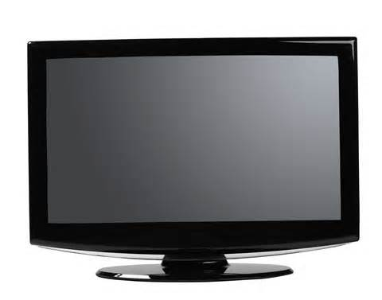
Recommended Documentaries
Get on and see what you think!
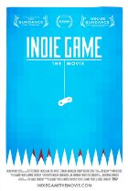
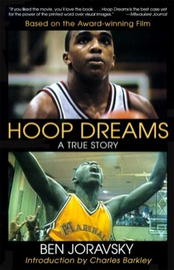
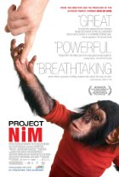
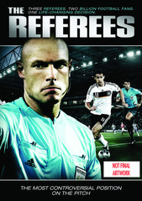
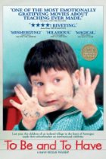
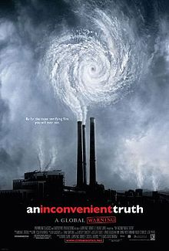

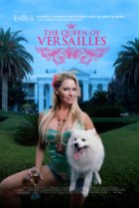
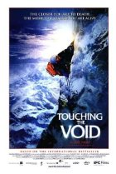
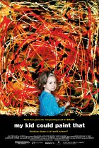
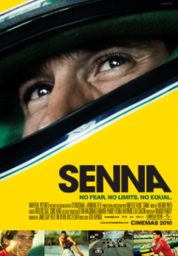
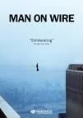
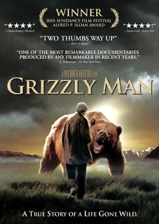

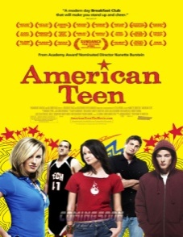
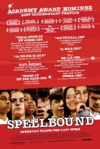
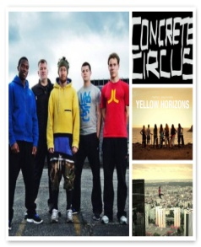
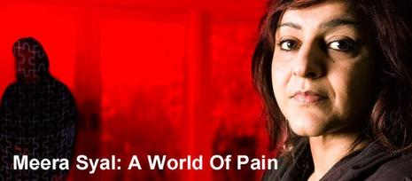
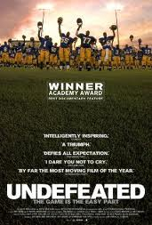

REASON TO READ #4 Find your own answers to life’s big questions. By following themes in the great books, films and documentaries, you’ll realize that certain topics are discussed over and over again throughout history: “What is our destiny? What is a good life? How can we achieve a good society? What can we learn to guide us through the mazes of the future from history, philosophy and religion, literature, and the fine arts?” Reading won’t give you an ultimate answer to the big questions. But, they will offer diverse views and possibilities.

A good newspaper is a nation talking to itself.” Arthur Miller
NON-FICTION TEXTS RECORD
DATE | ARTICLE | JOURNALIST’S ARGUMENT
REASON TO READ #5 Let a little genius rub off on you. The great books were written by some of the best minds in history. By reading them, your own mind can expand and your thoughts reach a higher plane. Sir Richard Livingston said: “We are tied down, all our days and for the greater part of our days, to the commonplace. This is where contact with great thinkers, great literature helps. In their company we are still in the ordinary world, but it is the ordinary world transfigured and seen through the eyes of wisdom and genius.”

FILM
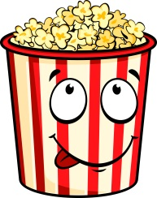
Been to the cinema this weekend? Watched a DVD with friends? Did you know you can “read” a film? Next time you watch a film, consider one of two of the following features and add your thoughts on it to your Reading Challenge.

- Setting (Geographical, Historical, Social Milieu)
- Cinematography (Camera Placement and Movement; Lighting; Colour; Focus; Frame
- Lighting (Realist; Romantic; Expressive; "Dark"; "Surreal")
- Decor/Clothing
- Pace (Fast-Paced; Slow-Paced; "Meditative"; "Poetic")
- Suspense
- Sound (Realistic; Expressive; Simple vs. Multi-Layered)
- Music (Soundtrack vs. Source)
- Editing--Cutting for Continuity; Cutting Within a Scene; Cross-Cutting (Parallel
- Editing); Metaphorical/
Symbolic Cutting

- Character (Complexity, Development, Believability)
- Plot (Story, Subplots, Drama)
- Narrative Structure (Straightforward vs. Complex; Flashbacks)
- Conflict
- Point of View
- Themes (Issues, Ideological Conflicts, Lessons Learned)

Film | Star Rating? * * * * * | Stand out feature? This can be good or bad!

Create a PINBOARD of your favourite print adverts here.

REASON TO READ #6
Learn from past mistakes. Everyone has to forge his or her own path in this life. But, why not see how others conquered the same challenges?

buzzfeed listicle
- Lord of the Flies, by William Golding—12 Reasons Boys Should Always Be Supervised
- The Jungle, by Upton Sinclair—20 Things You Didn’t Want to Know About Where Your Steak Comes From
- Ulysses, by James Joyce—13 Things to Do in Dublin while Your Wife is Cheating on You
- The Sun Also Rises, by Ernest Hemingway—7 Signs You’re Definitely in the Friend Zone
- The Prime of Miss Jean Brodie, by Muriel Spark—10 Signs Your Teenage Girlfriends Are Actually Frenemies
- Catch-22, by Joseph Heller—101 Reasons War Makes Absolutely No Sense
- Romeo and Juliet, by William Shakespeare—8 Ways Your Family Keeps You From Seeing Your Crush
- The Giving Tree, by Shel Silverstein—13 Signs Your Friendship is a One-Way Street
- Crime and Punishment, by Fyodor Dostoevsky—12 Reasons Murder and Radical Ideology Are Stressful
- Green Eggs and Ham, by Dr. Seuss—10 Reasons Picky Eaters Are the Worst
- Hamlet, by William Shakespeare—2 Reasons Your Uncle is the Worst

listicle
ˈlɪstɪk(ə)l/
noun
noun: listicle; plural noun: listicles
- a piece of writing or other content presented wholly or partly in the form of a list.
"a recent BuzzFeed listicle called ‘21 Pictures That Will Restore Your Faith in Humanity’ has attracted more than 13 million views

YOUR TASK:

- Make a listicle about your book.

- Make your book into a listicle.

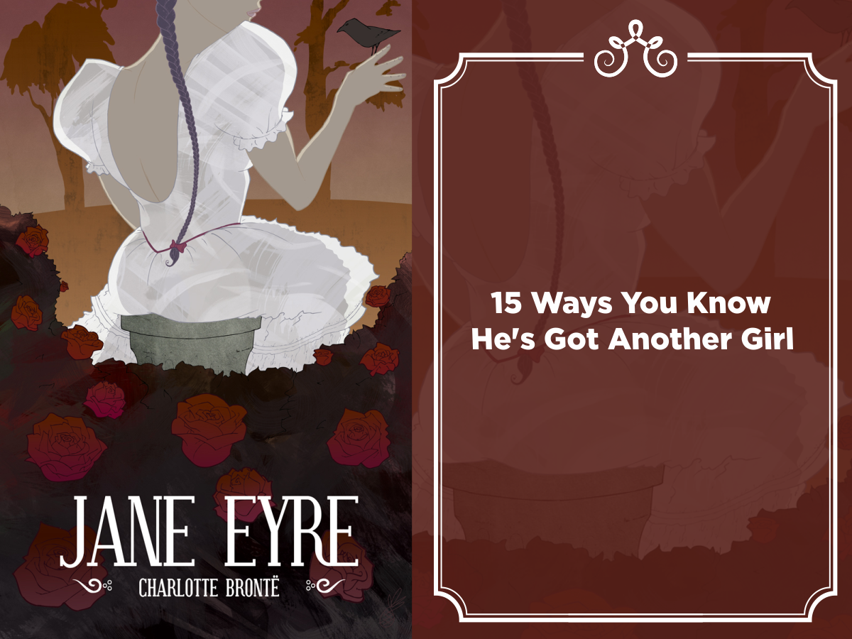

- Did you meet your Reading Challenge this year?
- Are you happy with the time you’ve spent reading this year or could you find time to do more?
- Has reading been important to you this year? How has it helped you?
- What’s been your most challenging read? What’s been your most enjoyable?
- Write a little in the box below to reflect on your reading habit this year. What will be your future targets for reading?

REASON TO READ #7: Join in the great conversation. Ultimately, the great writing makes up a conversation that spans mortal time and space. The Romans respond to the Greeks, the authors of the middle ages express their reaction to the Romans, and so on. Modern-day authors are responding to ideas first expressed hundreds of years ago. Once you have a grasp of what has been said in this unending conversation, you’ll be prepared to join in. You may even write a book or a blog, have a discussion with a friend, or post on a message board.

We’ll use this table, at home and in school, so that we can keep up with how many books that you’ve read during the challenge!
What have you been reading? | English teacher’s signature and comment (optional): | Parent’s signature and comment (optional):
S3
During Term 1?

During Term 2?

During Term 3?
S4
During Term 1?

During Term 2?

During Term 3?

Booklist
This is the top 100 books to read before you leave secondary school, as voted by teachers. How many have you read?

1. 1984 by George Orwell
2. To Kill A Mockingbird by Harper Lee
3. Animal Farm by George Orwell
4. Lord of the Flies by William Golding
5. Of Mice and Men by John Steinbeck
6. The Harry Potter Series by JK Rowling
7. A Christmas Carol by Charles Dickens
8. The Catcher in the Rye by JD Salinger
9. Great Expectations by Charles Dickens
10. Pride and Prejudice by Jane Austen
11. The Curious Incident of the Dog in the NightTime by Mark Haddon
12. The Boy in the Striped Pyjamas by John Boyne
13. Jane Eyre by Charlotte Bronte
14. Brave New World by Aldous Huxley
15. Wuthering Heights by Emily Bronte
16. Frankenstein by Mary Shelley
17. Birdsong by Sebastian Faulks
18. A Kestrel for a Knave by Barry Hines
19. The Lord of the Rings trilogy by JRR Tolkien
20. Danny, Champion of the World by Roald Dahl
21. The Great Gatsby by F Scott Fitzgerald
22. The Book Thief by Markus Zusak
23. The Kite Runner by Khaled Hosseini
24. A Clockwork Orange by Anthony Burgess
25. A Passage to India by EM Forster
26. Private Peaceful by Michael Morpurgo
27. The Hobbit by JRR Tolkien
28. A Monster Calls by Patrick Ness
29. Adventures of Huckleberry Finn by Mark Twain
30. Holes by Louis Sachar
31. Catch-22 by Joseph Heller
32. The Noughts and Crosses trilogy by Malorie Blackman
33. Strange Case of Dr Jekyll and Mr Hyde by Robert Louis Stevenson
34. War Horse by Michael Morpurgo
35. Atonement by Ian McEwan
36. The Hunger Games trilogy by Suzanne Collins
37. His Dark Materials by Philip Pullman
38. Dracula by Bram Stoker
39. Fahrenheit 451 by Ray Bradbury
=40. A Room With a View by EM Forster
=40. Beloved by Toni Morrison
42. Wonder by RJ Palacio
43. Emma by Jane Austen
44. Gulliver's Travels by Jonathan Swift
=45. Half a Yellow Sun by Chimamanda Ngoxi Adichie
=45. The Color Purple by Alice Walker
47. Oliver Twist by Charles Dickens
48. The Sherlock Holmes series by Arthur Conan Doyle
49. Cider with Rosie by Laurie Lee
50. One Flew Over the Cuckoo's Nest by Ken Kesey
51. Anita and Me by Meera Syal
52. The Discworld series by Terry Pratchett
53. Around the World in Eighty Days by Jules Verne
54. Skellig by David Almond
55. Life of Pi by Yann Martel
56. Tess of the d'Urbervilles by Thomas Hardy
57. The Artemis Fowl series by Eoin Colfer
58. A Modest Proposal by Jonathan Swift
59. My Family and Other Animals by Gerald Durrell
60. Things Fall Apart by Chinua Achebe
61. Brighton Rock by Graham Greene
62. Never Let Me Go by Kazuo Ishiguro
63. The Fault In Our Stars by John Green
64. Dubliners by James Joyce
65. Face by Benjamin Zephaniah
66. When Hitler Stole Pink Rabbit by Judith Kerr
67. White Teeth by Zadie Smith
68. Treasure Island by Robert Louis Stevenson
=69. Cry, the Beloved Country by Alan Paton
=69. Little Women by Louisa May Alcott
=71. Do Androids Dream of Electric Sheep? by Philip K Dick
=71. I am David by Anne Holm
=73. The Bell Jar by Sylvia Plath
=73. The Picture of Dorian Gray by Oscar Wilde
=73. V for Vendetta by Alan Moore and David Lloyd
76. The Grapes of Wrath by John Steinbeck
77. A Song of Ice and Fire series by George RR Martin
78. The Old Man and the Sea by Ernest Hemingway
=79. Angus, Thongs and Full-Frontal Snogging by Louise Rennison
=79. Empire of the Sun by JG Ballard
=79. On the Road by Jack Kerouac
82. The Mayor of Casterbridge by Thomas Hardy
=83. A Portrait of the Artist as a Young Man by James Joyce
=83. Billy Liar by Keith Waterhouse
=83. The Adventures of Tom Sawyer by Mark Twain
=86. A Gathering Light by Jennifer Donnelly
=86. Heroes by Robert Cormier
88. Refugee Boy by Benjamin Zephaniah
=89. One Day in the Life of Ivan Denisovich by Aleksandr Solzhenitsyn
=89. Schindler's Ark by Thomas Keneally
91. Forever by Judy Blume
=92. Coram Boy by Jamila Gavin
=92. Stone Cold by Robert Swindells
94. A Time to Dance by Bernard MacLaverty
=95. Cat's Eye by Margaret Atwood
=95. Cloud Atlas by David Mitchell
=97. The War of the Worlds by HG Wells
=97. The Tracy Beaker series by Jacqueline Wilson
=99. Bridge to Terabithia by Katherine Paterson
=99. Kidnapped by Robert Louis Stevenson
=99. The Time Machine by HG Wells

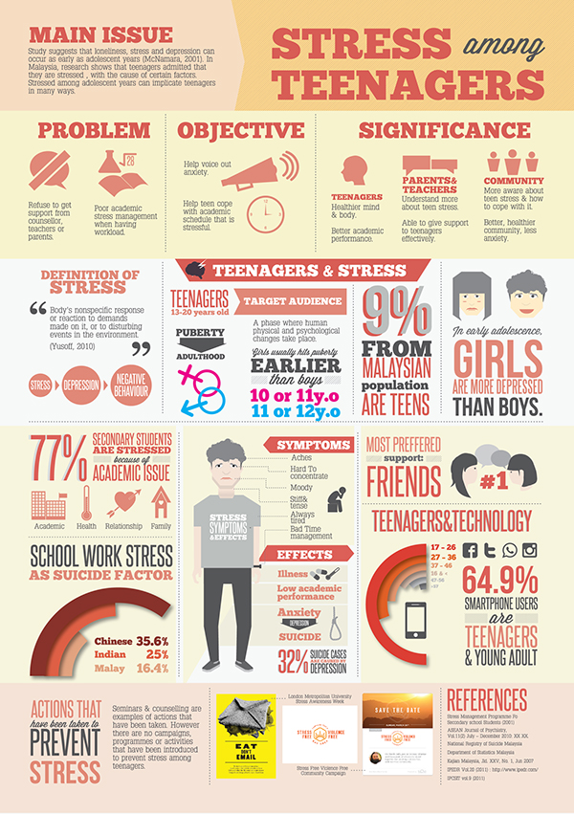
WRITING

Inform

Discuss: What causes
stress among teenagers
and how
it can be reduced.
The difference between
fact and opinion.

Write: To give information about the main cause of stress among teenagers, its main effect and a solution
__________________________________________________________________________________________________________________________________________________________________________________________________________________________________________________________________________________________________________________________________________________________________________________________________________________________________________________________________
______________________________________________________________________________________________________________________________________________________

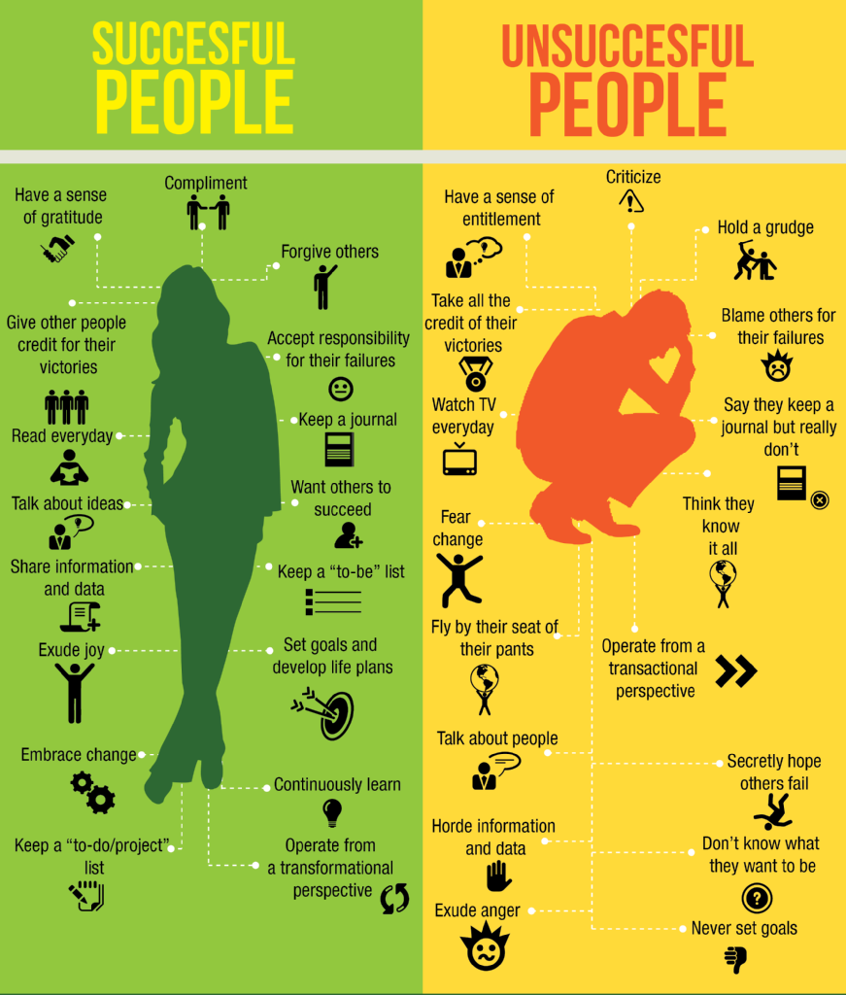
Compare and Contrast

Discuss: How you ensure
success in a task and the
things that get in the way
of your success

Write: To compare the behaviour of successful and unsuccessful people.
__________________________________________________________________________________________________________________________________________________________________________________________________________________________________________________________________________________________________________________________________________________________________________________________________________________________________________________________________
___________________________________________________________________________________________________________________________________________________________________________________________________________________________________________________________________________________________________________________________________________________________________________________________________________________________________________________________________________________________________________________________________________________________________________________________________________________________________________________________________________________________________
Inspire
Four score and seven years ago our fathers brought forth on this continent, a new nation, conceived in liberty, and dedicated to the proposition that all men are created equal.
Now we are engaged in a great civil war, testing whether that nation, or any nation so conceived and so dedicated, can long endure. We are met on a great battlefield of that war. We have come to dedicate a portion of that field, as a final resting place for those who here gave their lives that that nation might live. It is altogether fitting and proper that we should do this.
But in a larger sense, we cannot dedicate – we cannot consecrate – we cannot hallow – this ground. The brave men, living and dead, who struggled here, have consecrated it, far above our poor power to add or detract. The world will little note, nor long remember, what we say here, but it can never forget what they did here. It is for us the living, rather, to be dedicated here to the unfinished work which they who fought here have thus far so nobly advanced. It is rather for us to be here dedicated to the great task remaining before us – that from these honoured dead we take increased devotion to that cause for which they gave the last full measure of devotion – that we here highly resolve that these dead shall not have died in vain – that this nation, under God, shall have a new birth of freedom – and that government of the people, by the people, for the people, shall not perish from the earth.
Abraham Lincoln – The Gettysburg Address, Nov 19 1863
Read Lincoln’s famous speech and watch the following speeches
JFK - We choose to go to the moon https://www.youtube.com/watch?v=g25G1M4EXrQ
Braveheart
https://www.youtube.com/watch?v=hIvRkjOd1f8
Discuss: what makes an inspirational speech?
Write: Imagine you are a football manager or other sports coach before an important final.
Write the speech you will give to motivate your team OR Imagine you are a king/queen/ leader who has just come to power. Write your speech to your subjects, telling them what sort of ruler you are going to be.
_________________________________________________________________________________________________________________________________________________________________________________________________________________________________________________________________________________________________________________________________________________________________________________________________________________________________________________________________
________________________________________________________________________________________________________________________________________________________________________________________________________________________________________________________________________________________________________________________________________________________________________________________________________________________________________________________________________________________________________________________________________________________________________________________________________________________

Compare two fast foods/ or two fast food restaurants. Say which you prefer and why.
OR
Present an argument in favour of a four-day school week.
OR
Write an argument against school uniform.
OR
You are the only carrot left in the fridge. Write about your feelings and your hopes for the future.
OR
You are an old coin that someone has found in the street. Write about your life.
OR
What if humans had tails? Write a short essay in which you explain how the world would be different.
OR
Write a review of a meal you recently enjoyed. Describe it and say what you liked about it and what could make it even better.
OR
Write a review an item of clothing that you like to wear: shoes, jacket, leisure wear, hats etc…
OR
Write a review of a place you have recently visited. Point out its most notable features and say what you liked/disliked about it.
OR
Write a page about the rules of a game that you play or have played when you were younger.
OR
Write a set of instructions on how to stay in bed as long as possible but still get to school on time
OR
What if you were invisible? Describe what things you would do and where you would like to go.
OR
“Kids believe anything.” Did you believe anything as a child that you later found out to be untrue?
OR
Write a letter to the head teacher of your school requesting that all tests and exams be banned.

TALKING

S3 English Exam: Spoken Performance
As part of your S3 assessment you are going to take part in a group discussion on a topic/question. Your contributions will be based on yoru own knowledge/experience and on the selection of sources you will be given/directed to.
You will be in a mixed group of 5 or 6 pupils who will have 15 minutes to discussthe topic.
Your performance in this discussion will count towards your N4 or N5 qualification.
You may bring notes or ideas for questions you wish to ask of others.
You will be assessed on your contributions and your ability to listen to and respond to others.
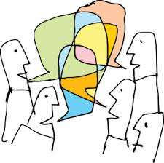
The 4 assessment criteria are:
- Selecting significant ideas and content, using a format and structure appropriate to purpose and audience
- Applying knowledge and understanding of language in terms of language choice
- Communicating meaning at first hearing
- Using significant aspects of non-verbal communication

Remember the key features of high quality group discussion – these are the things your assessor will be looking for during your discussion:
- Can you make clear relevant points?
- Can you develop your ideas?
- Can you make effective use of notes/ evidence?
- Can you stick to the purpose of the discussion?
- Can you listen to others exploring, building upon and expanding on their ideas
- Can you help to ensure that everyone gets involved?
- Can you ask questions of others or answer questions posed by others?
- Can you clarify or summarise what the group or individual group members are saying?
- Can you challenge the views of others while recognising that they have the right to views different from your own?
- Can you ensure you are clear and audible throughout?
- Can you make regular eye contact?
- Can you show enthusiasm?
- Can you use a wide range of verbal and non-verbal techniques e.g. body language, pace, tone, gesture, emphasis, register, rhetorical devices?
Here are some phrases that you can use to help you to contribute during discussion:

Starting A Discussion
- The question up for discussion is…?
- We need to decide…?
- The group has been asked to look at…?
- To begin with…?
- Why don’t we start by…?
Challenging
- I see what you mean but…
- I am not sure I agree because…
- An alternative view would be…
- I see your point but it’s also true that…
Encouraging others/asking questions
- Could I ask…?
- What do you think _______?
- Does anyone agree or disagree with that point?
- Have we gone into enough detail?
- Would anyone like to comment on that?
- Let’s make sure we hear from everyone.
- I wonder if…?
Moving the Discussion on
- I think we should move on to the next point.
- We have other areas to consider
- Could we move on to considering…?
- Why don’t we move on and come back to this if necessary?
Making a Contribution
- I think one of the key points is…
- In my opinion . . .
- It seems to me . . .
- I feel that . . .
Developing Points
- For example/for instance…
- Because…
- This is due to…
- What I mean by this is…
- My evidence for this is…
- My reasons are…
Building on Contributions
- I’d like to add to that by saying…
- Just to build on _________’s point
- Another example is…
Clarifying
- In other words, are you saying that…?
- Just to be clear, do you mean it is……?
- Am I right in understanding that….?
Summarising
- I think there are a few key ideas.
- Here’s where I think we are
- Do you agree that the main points are…

