Note-taking: The Cornell Method
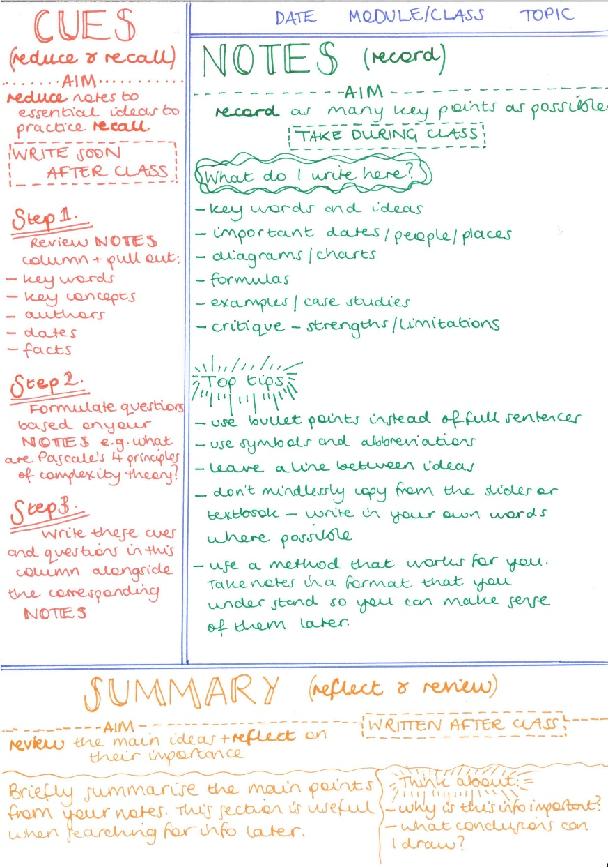
When you are taking notes in class or from an on or off line source, the Cornell method can be very useful in helping you to clarify your thinking, see where the gaps in your knowledge are and to prevent you from plagiarising from something you have read. This method also improves your summarising skills.
