1 | 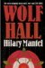 | Wolf Hall (Thomas Cromwell, #1)  by  Hilary Mantel
2 | 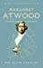 | The Blind Assassin  by  Margaret Atwood (Goodreads Author)
3 | 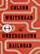 | The Underground Railroad  by  Colson Whitehead (Goodreads Author)
4 | 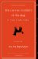 | The Curious Incident of the Dog in the Night-Time  by  Mark Haddon
5 | 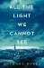 | All the Light We Cannot See  by  Anthony Doerr (Goodreads Author)
6 | 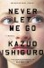 | Never Let Me Go  by  Kazuo Ishiguro
7 | 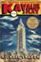 | The Amazing Adventures of Kavalier & Clay  by  Michael Chabon
8 | 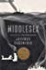 | Middlesex  by  Jeffrey Eugenides
9 | 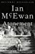 | Atonement  by  Ian McEwan
10 | 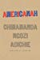 | Americanah  by  Chimamanda Ngozi Adichie
10 |  | The Essex Serpent  by  Sarah Perry
12 | 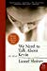 | We Need to Talk About Kevin  by  Lionel Shriver (Goodreads Author)
13 | 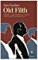 | Old Filth (Old Filth, #1)  by  Jane Gardam
14 | 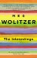 | The Interestings  by  Meg Wolitzer
15 | 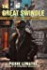 | The Great Swindle  by  Pierre Lemaitre
15 | 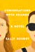 | Conversations with Friends  by  Sally Rooney (Goodreads Author)
17 | 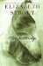 | Olive Kitteridge (Olive Kitteridge, #1)  by  Elizabeth Strout
18 | 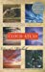 | Cloud Atlas  by  David Mitchell
19 | 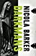 | Darkmans (Thames Gateway, #3)  by  Nicola Barker
20 | 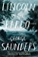 | Lincoln in the Bardo  by  George Saunders
21 | 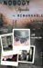 | If Nobody Speaks of Remarkable Things  by  Jon McGregor
22 |  | Submission  by  Michel Houellebecq
23 | 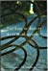 | The Line of Beauty  by  Alan Hollinghurst
24 | 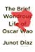 | The Brief Wondrous Life of Oscar Wao  by  Junot Díaz
25 | 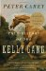 | True History of the Kelly Gang  by  Peter Carey
26 | 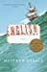 | English Passengers  by  Matthew Kneale
27 | 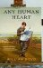 | Any Human Heart  by  William Boyd
28 | 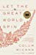 | Let the Great World Spin  by  Colum McCann (Goodreads Author)
29 | 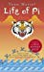 | Life of Pi  by  Yann Martel
30 | 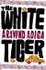 | The White Tiger  by  Aravind Adiga
31 | 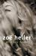 | Notes On A Scandal  by  Zoë Heller
32 | 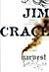 | Harvest  by  Jim Crace
33 | 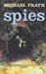 | Spies  by  Michael Frayn
34 | 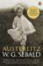 | Austerlitz  by  W.G. Sebald
35 | 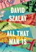 | All That Man Is  by  David Szalay
36 | 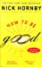 | How to Be Good  by  Nick Hornby
37 | 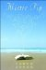 | Mister Pip  by  Lloyd Jones
38 | 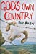 | God's Own Country  by  Ross Raisin
39 | 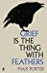 | Grief is the Thing with Feathers  by  Max Porter
40 | 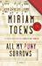 | All My Puny Sorrows  by  Miriam Toews
41 | 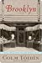 | Brooklyn  by  Colm Tóibín
42 | 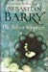 | The Secret Scripture  by  Sebastian Barry
43 | 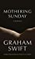 | Mothering Sunday  by  Graham Swift
44 | 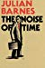 | The Noise of Time  by  Julian Barnes
45 | 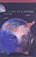 | Legend of a Suicide  by  David Vann (Goodreads Author)
46 | 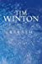 | Breath  by  Tim Winton
47 | 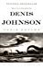 | Train Dreams  by  Denis Johnson
48 | 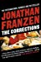 | The Corrections  by  Jonathan Franzen
49 | 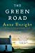 | The Green Road  by  Anne Enright
50 | 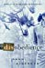 | Disobedience  by  Naomi Alderman (Goodreads Author)
51 | 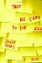 | Then We Came to the End  by  Joshua Ferris (Goodreads Author)
52 | 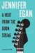 | A Visit from the Goon Squad  by  Jennifer Egan (Goodreads Author)
53 | 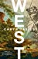 | West  by  Carys Davies (Goodreads Author)
54 | 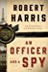 | An Officer and a Spy  by  Robert Harris (Goodreads Author)
55 | 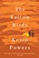 | The Yellow Birds  by  Kevin Powers
56 | 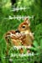 | Hope: A Tragedy  by  Shalom Auslander
57 | 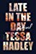 | Late in the Day  by  Tessa Hadley
58 | 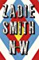 | NW  by  Zadie Smith
59 | 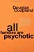 | All Families are Psychotic  by  Douglas Coupland (Goodreads Author)
60 | 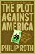 | The Plot Against America  by  Philip Roth
61 | 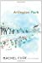 | Arlington Park  by  Rachel Cusk
62 | 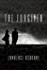 | The Forgiven  by  Lawrence Osborne (Goodreads Author)
63 | 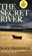 | The Secret River  by  Kate Grenville
64 | 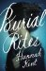 | Burial Rites  by  Hannah Kent (Goodreads Author)
65 | 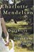 | Daughters of Jerusalem  by  Charlotte Mendelson
66 | 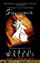 | Fingersmith  by  Sarah Waters
67 | 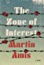 | The Zone of Interest  by  Martin Amis
68 | 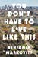 | You Don't Have to Live Like This  by  Benjamin Markovits
69 | 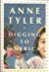 | Digging to America  by  Anne Tyler
70 | 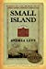 | Small Island  by  Andrea Levy
71 | 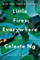 | Little Fires Everywhere  by  Celeste Ng (Goodreads Author)
72 | 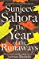 | The Year of the Runaways  by  Sunjeev Sahota
73 | 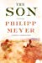 | The Son  by  Philipp Meyer (Goodreads Author)
74 | 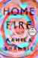 | Home Fire  by  Kamila Shamsie
75 | 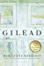 | Gilead (Gilead, #1)  by  Marilynne Robinson
76 | 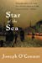 | Star of the Sea  by  Joseph O'Connor
77 | 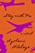 | Stay with Me  by  Ayọ̀bámi Adébáyọ̀ (Goodreads Author)
78 | 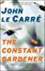 | The Constant Gardener  by  John le Carré
79 | 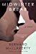 | Midwinter Break  by  Bernard MacLaverty
80 | 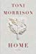 | Home  by  Toni Morrison
81 | 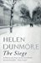 | The Siege (The Siege, #1)  by  Helen Dunmore
82 | 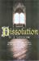 | Dissolution (Matthew Shardlake, #1)  by  C.J. Sansom
83 | 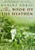 | The Book of the Heathen: A Novel of the Congo  by  Robert Edric
84 | 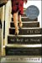 | I'll Go to Bed at Noon  by  Gerard Woodward (Goodreads Author)
85 | 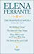 | The Neapolitan Novels  by  Elena Ferrante
86 | 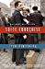 | Suite Française  by  Irène Némirovsky
87 | 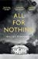 | All for Nothing  by  Walter Kempowski
88 | 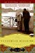 | The Yacoubian Building  by  Alaa Al Aswany
89 | 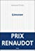 | Limonov  by  Emmanuel Carrère
90 | 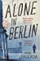 | Alone in Berlin  by  Hans Fallada
91 | 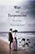 | War and Turpentine  by  Stefan Hertmans
92 | 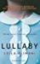 | Lullaby  by  Leïla Slimani
93 | 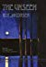 | The Unseen  by  Roy Jacobsen
94 | 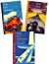 | Your Face Tomorrow: Fever and Spear / Dance and Dream / Poison, Shadow, and Farewell (Your face tomorrow, #1-3)  by  Javier Marías
95 | 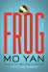 | Frog  by  Mo Yan
96 | 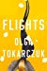 | Flights  by  Olga Tokarczuk
97 | 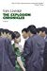 | The Explosion Chronicles  by  Yan Lianke
98 | 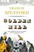 | Golden Hill  by  Francis Spufford (Goodreads Author)
99 | 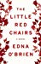 | The Little Red Chairs  by  Edna O'Brien
100 | 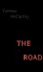 | The Road  by  Cormac McCarthy

