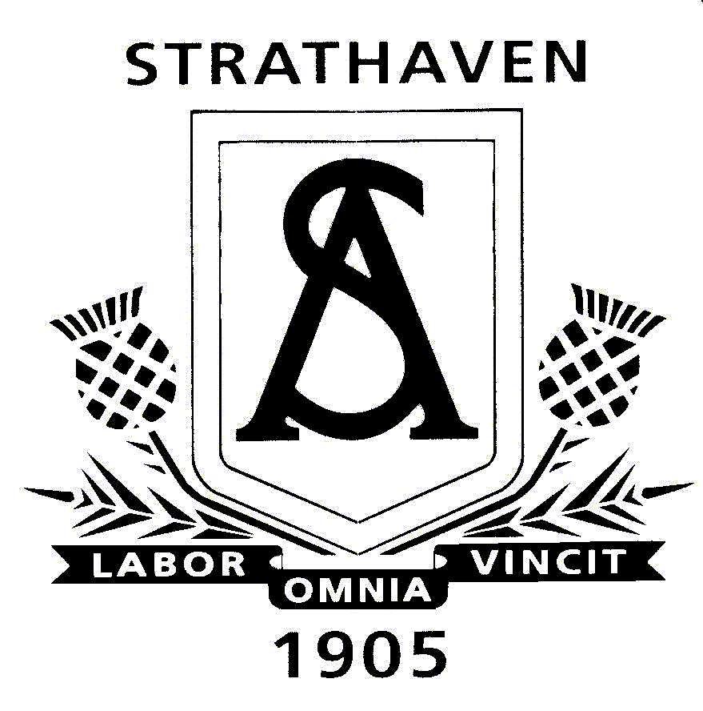
Strathaven Academy Maths Department
S2 Level 3 Course Outline

Unit 4 –
- Scale Drawing
- 3D Shape
- Volume
- Money UNIT 4 TEST - October

Unit 5 –
- Circles
- Quadrilaterals
- Special Numbers
- Drawing Triangles UNIT 5 TEST - January

Unit 6 –
- Distributive Law
- Equations
- Statistics – Pie Charts
- Probability
- Fractions

END OF S2 TEST - APRIL

