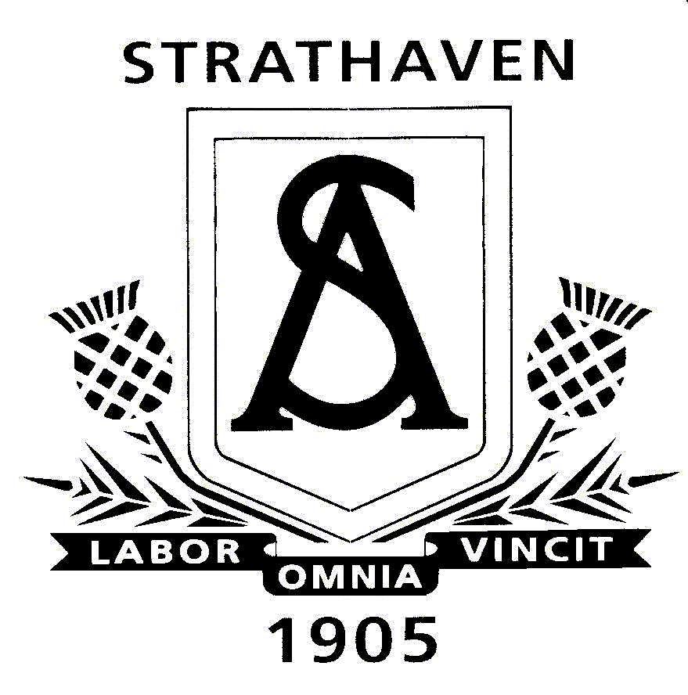
Strathaven Academy Maths Department
S1 Level 3 Course Outline

Unit 1 – (August – October)
- Whole Numbers
- Symmetry
- Decimals
- Statistics UNIT 1 TEST - October

Unit 2 – (October – January)
- Negative Numbers and Coordinates
- Time
- Algebra
- Fractions and Percentages UNIT 2 TEST – January

Unit 3 – (January – April)
- Length and Area
- Ratio
- Angles
- Patterns

END OF S1 TEST - APRIL

